**DAY:THURSDAY**

**DATE:25-08-2022**

Operating system is a system software which acts as a interface between user and

computer.

why do we use Windows 10 mostly?

because it is user friendly

major differnece between os is versions.

windows is closed source OS

linux is open source OS

We have different versions of OS .Few commands are updated

In DEVOPS why we need OS?

Devops is common for every cloud.But why we need Linux OS?Windows is not having security

and no rules and closed source

But Linux and CentOs are open source and secure.

For using DEVOPS we are using linux commands only.

Os is used as GUI and CLI:

GUI-Graphical user interface-->You can see the images

CLI-Command line interface-->you use commands.

No one use windows in software industry.They use linux.

We have to give commands in linux.

Operating Systems:

These are based on linux:

CentOs

fedora

ubuntu

kali linux--for ethical hacking--we dont know from where the data is coming and

where data is sent

where we learn linux commands?

To learn linux commands we have to install virtual machine

Difference between virtual and physical is physical means you can touch

but virtual you cannot touch

Inside windows we can install VMWARE

VMWARE is also a machine where we can manage any operating systems at a time

In the VMWAre we can create a windows,redhat,centos,ubuntu os etc.

In the virtual machine we can increase the RAM by using options

But in physical machine if we have 4GB ram then buy another 4GB ram and remove screws

and insert ram in the machine

Different VMWARE are available ,all works same.

Some softwares will run only in older versions for that purpose also we use VMWARE.

**press start button to turn on virtual machine

To create a virtual machine of REdhat OS:

go to new

give name-->next

go to ram-->give 4 GB-->

harddisk-->next

now when you start the OS-->nothing will happen because we didnt give OS image.

so now select the disk then it will load

So now we are using two operating systems

What cloud provides?

cloud providers will provide a virtual PC's

AWS will provide virtual PC's

In Technical hub nearly 100 employees are there --work from home

How can the employees share their work?

so they make use of AWS.

AWS will provide virtual PCs

Cloud providers will help us to create new features.

Open virtual machine:

cd directoryname-->to change directory

cd .. to come out of desktop

ls list information of files.

cat filename to open a file

mkdir filename

**DAY:FRIDAY**

**DATE:26-08-2022**

**LINUX introduction**

**basic commands**

**What is VMWARE**

**LINUX installation**

**vi commands and what is the use**

**Difference between user and Graphical interface**

**File permissions**

**Disk permission or Disk creating**

**Structure of Linux:**

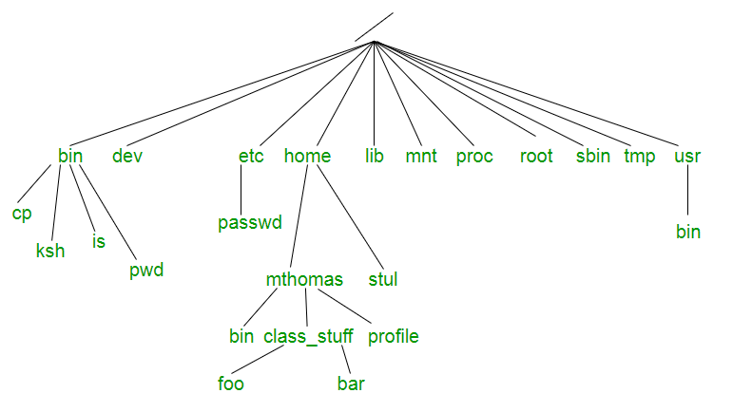

So, using the above Linux file system chart, we must study what each folder in the Linux file system is for in order to gain a better understanding of how Linux works in general. It should be noted that not every folder described here or illustrated above is present in every Linux distribution, but the vast majority of them are.

**/ – this is known as “root”, the logical beginning of the Linux file system structure. Every single file path in Linux begins from root in one way or another. / contains the entirety of your operating system.**

**/bin** – Pronounced “bin” (as opposed to “bine”), this is where most of your binary files are stored, typically for the Linux terminal commands and core utilities, such as cd (change directory), pwd (print working directory), mv (move), and so on.

**/boot** – This is where all the needed files for Linux to boot are kept. Many people, including myself, like to keep this folder in it’s own separate partition on the hard drive, especially when dual-booting is involved. A key thing to note is that even when **/boot** is stored on different partition, it is still logically located at /boot as far as Linux is concerned.

**/dev** – This is where your physical devices are mounted, such as your hard drives, USB drives, optical drives, and so on. We’ve already explored that typically, your system hard drive is mounted under /dev/sda, whereas your USB thumb drive might be mounted under /dev/sde. You may also have different partitions on your disk, so you’ll see /dev/sda1, /dev/sda2, and so on. In Windows, when you go to “My Computer” or “Computer” and you can see all of the physical devices and drives connected to your computer, this is the equivalent of /dev in **Linux file structure**.

**/etc** – Pronounced “et-see”, although some also prefer to spell it out, is where configuration files are stored. Configurations stored in /etc will typically affect all users on the system; whereas users can also store configuration files under their own /home folders, which will only affect that particular user.

**/home** – This is where you’ll spend the vast majority of your time because it has all of your personal data. The /home/username directory contains the Desktop, Documents, Downloads, Photos, and Videos folders. If you choose, you can keep files directly in your /home folder rather than in a sub-folder. When you open a command-line terminal in Linux, the terminal typically links to your /home/username folder, unless you’ve manually altered the default destination to something else.

**/lib** – This is the location of libraries. When installing Linux software packages, you’ll notice that additional libraries are frequently downloaded, and they almost always begin with lib-something. These are the files required for your Linux apps to function. This folder is similar to, but not exactly the same as, the Program Files folder in Windows.

Unlike Windows, libraries can be shared between many distinct programmes, resulting in Linux installations that are often far lighter than Windows, because in Windows, each programme requires its own library, even if it is redundant and already existing for another programme. Certainly an advantage of the Linux file system structure.

**/media** – Another place where external devices such as optical drives and USB drives can be mounted. This varies between different Linux distros.

**/mnt** – This is basically a placeholder folder used for mounting other folders or drives. Typically this is used for Network locations, but you could really use it for anything you want. I used to use it as the mount point for my media server’s hard drive (/mnt/server).

**/opt** – Optional software for your system that is not already managed by your distro’s package manager. I don’t really ever find myself using this, your mileage may vary.

**/proc** – The “processes” folder where a lot of system information is represented as files (remember, everything is a file). It basically provides a way for the Linux kernel (the core of the operating system) to send and receive information from various processes running in the Linux environment.

**/root** – This is the equivalent to the /home folder specifically for the root user, also called the superuser. You really don’t want to touch anything in here unless you know what you’re doing.

**/sbin** – Similar to /bin, except that it’s dedicated to certain commands that can only be run by the root user, or the superuser.

**/tmp** – This is where temporary files are stored, and they are usually deleted upon shutdown, which saves you from having to manually delete them like is required in Windows.

**/usr** – Contains files and utilities that are shared between users.

**/var** – This is where variable data is kept, usually system logs but can also include other types of data as well.

You can do further study online and dive deeper to learn more about specific programmes and usage of each of the above-mentioned folders, but for the average everyday home user, your /home folder is usually the only one with which you’ll be directly engaging.

If you’re troubleshooting, you may need to go into the other files, although most current Linux distributions automatically maintain these folders and require little to no user intervention.

**commands:**

ls

ls -l

touch file1 file2 file3

cd ../ ..

cd –

Bhanu@9